صورة تحتوي على دائرة كهربائية, الهندسة الإلكترونية, مكون إلكتروني, مكونات الدائرة الكهربائية

تم إنشاء الوصف تلقائياً Electronic Parts

KANAAN TEAM

Content

* **Main Diagram**
* **Arduino Mega 2560**
* **L298N Motor Driver**
* **DC voltage Buck**
* **DC Encoder Motor**
* **Servo Motor**
* **Battery**

Main Diagram

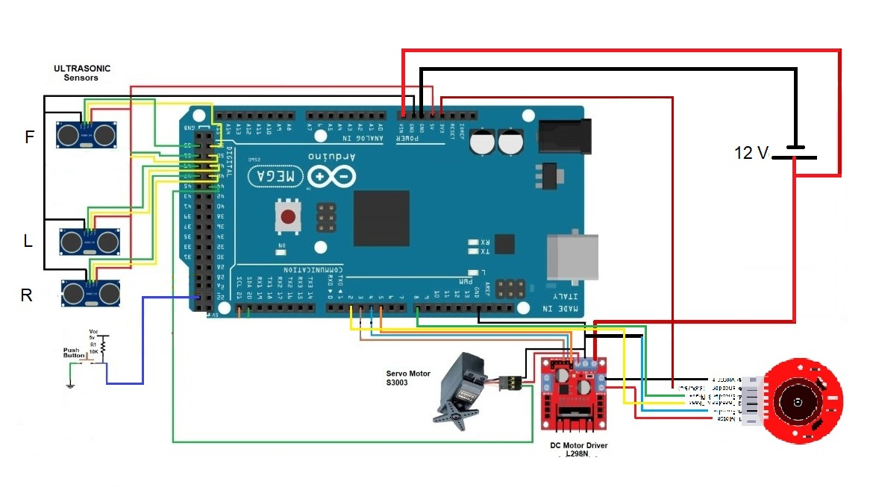

The electronic diagram illustrates the interconnection mechanism between the controllers and how the Arduino controller is linked to the Ultrasonic sensors and motor driver. The motor driver is responsible for governing both the DC motor and the servo.

Arduino Mega 2560

The Arduino microcontroller plays a pivotal role in controlling diverse electronic components through the following processes:

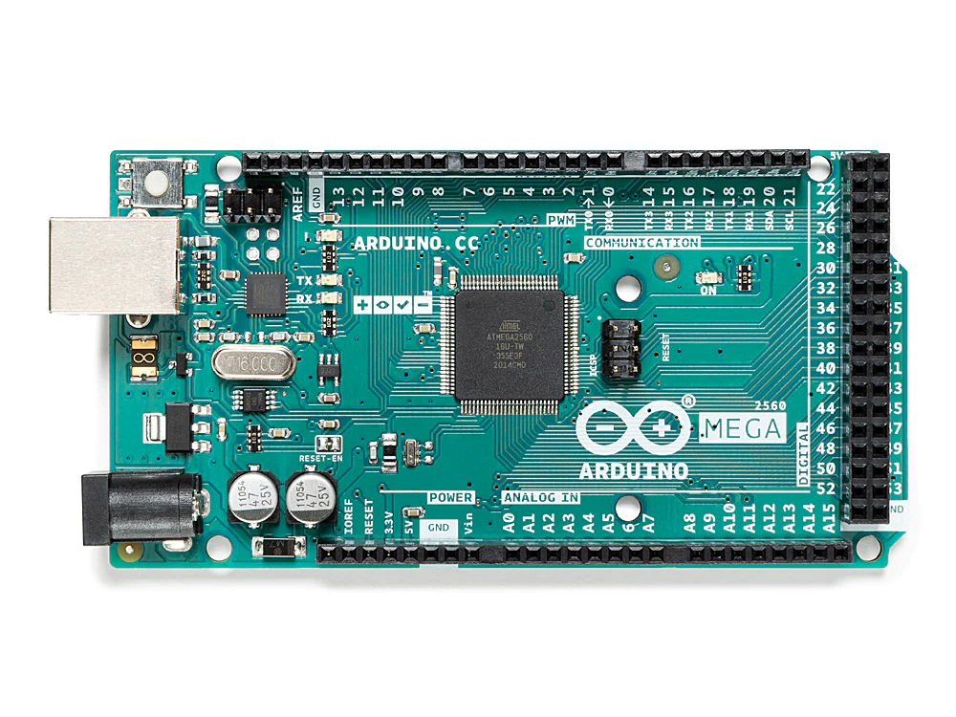Initially, it supervises the servo motor and DC motor by sending commands to the motor driver.

Subsequently, it measures the distances recorded by the front, back, and side ultrasonic sensors.

Furthermore, it regulates the RGB LEDs, granting the ability to manipulate their colors.

Lastly, it detects the push button to activate the vehicle's functions. It is noteworthy that the Arduino Nano has been replaced by the Arduino Mega. This change was made due to the benefits of using the Arduino Mega, which offers individual ports for each function without requiring multiplexing. This configuration allows for more efficient use of PWM (Pulse Width Modulation) capabilities. Additionally, the system reads the switch to facilitate code changes.

L298N Motor Driver

صورة تحتوي على مكونات الدائرة الكهربائية, مكون إلكتروني, دائرة كهربائية, مكون الدائرة السلبية

تم إنشاء الوصف تلقائياً

The motor driver serves a dual purpose, enabling both speed control for the DC motor and facilitating forward and backward motion, while also governing the movement of the servo motor.

Ultrasonic Sensors

صورة تحتوي على الإلكترونيات, مكبر الصوت, معدات الصوت, صندوق الصوت

تم إنشاء الوصف تلقائياً

A trio of sensors is employed, with one positioned at the front and two on the sides. These ultrasonic sensors play a crucial role in determining distances and the direction of the vehicle's movement, along with providing valuable insights into other pertinent aspects.

صورة تحتوي على نص, كابل, البطارية

تم إنشاء الوصف تلقائياً Battery

The vehicle relies on a battery to supply essential power. This battery configuration comprises three lithium batteries interconnected in series.

DC voltage Buck

**صورة تحتوي على مكون إلكتروني, الهندسة الإلكترونية, الإلكترونيات, مكونات الدائرة الكهربائية

تم إنشاء الوصف تلقائياً**

**This circuit is designed to reduce voltage, as it was used to supply power to the Servo Motor.**

DC Encoder Motor

صورة تحتوي على كابل, أسطوانة, الأسلاك الكهربائية, فضة/ لون فضي

تم إنشاء الوصف تلقائياً

The DC motor is physically linked to the rear wheels, enabling the vehicle's motion.

The reason for using an Encoder is to monitor the motor's direction and movement, which proves instrumental in controlling the overall movement of the vehicle.

صورة تحتوي على نص, أداة, كابل, البطارية

تم إنشاء الوصف تلقائياً Servo Motor

The servo motor assumes the responsibility of directing the vehicle by manipulating the steering wheel.

THANK YOU

KANAAN TEAM